Ideation Phase
Define the Problem Statements

Date | 17 February 2026
Team ID | LTVIP2026TMIDS66452
Project Name | ResolveNow: Your Platform for Online Complaints
Maximum Marks | 2 Marks

Customer Problem Statement Template:
Creating a well-articulated customer problem statement for ResolveNow is essential to understanding the citizen's point of view and focusing on what truly matters to create an experience people will love. This process allows our team to empathize with the challenges our users face, such as the frustration of not knowing the status of a reported issue or the difficulty of reaching the right authority. By documenting these challenges, we can align our MERN-stack solution to directly address the gap between a problem occurring and its final resolution, ensuring that every feature we build—from real-time tracking to direct agent messaging—is designed with the user’s perception and needs in mind.
The ideal solution for ResolveNow focuses on transforming the currently fragmented experience of filing complaints into a streamlined digital journey. A clear problem statement helps us realize that our customers aren't just looking for a technical portal; they are looking for transparency, speed, and accountability. Throughout the development process, this customer-centric approach will help us better understand how users perceive our service, allowing us to find the most effective technical solutions—like Socket.io for instant updates—to bridge the communication gap and build a platform that users can trust to solve their real-world problems.

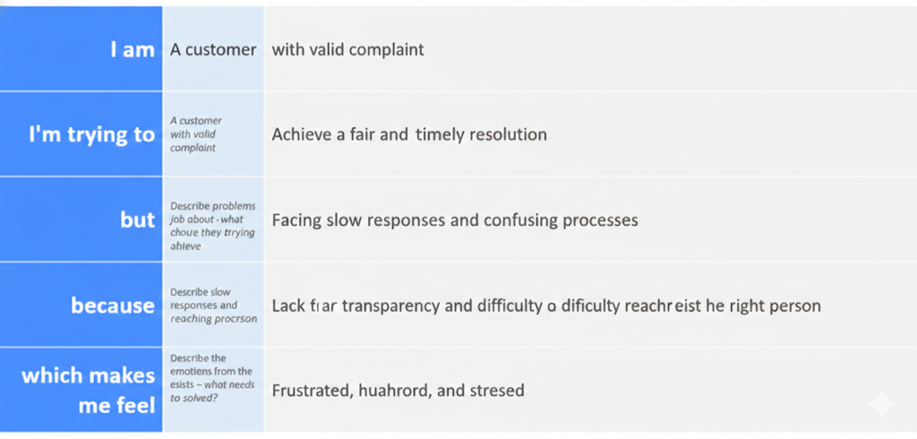
Example:
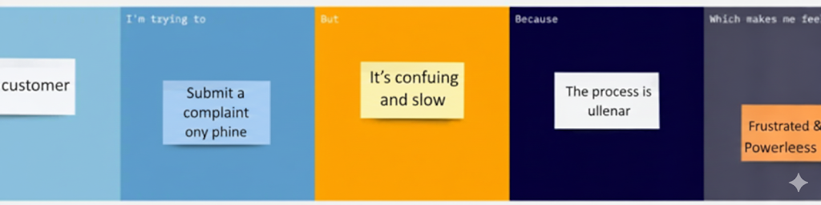
Problem Statement (PS) | I am (Customer) | I’m trying to | But | Because | Which makes me feel
PS-1 | A concerned citizen or local resident | Report an urgent community issue like a broken streetlight or water leak | I have no way to know if my complaint is being seen or worked on | The current system lacks real-time tracking and a centralized dashboard for updates | Frustrated, ignored, and disconnected from my local authorities
PS-2 | A department administrator or agent | Efficiently organize and resolve the high volume of daily complaints | Manual sorting and assignment of tickets is slow and leads to errors | There is no automated routing system or secure role-based access to manage data | Overwhelmed by the backlog and unable to provide timely solutions

